**Python Programming Assignment #2**

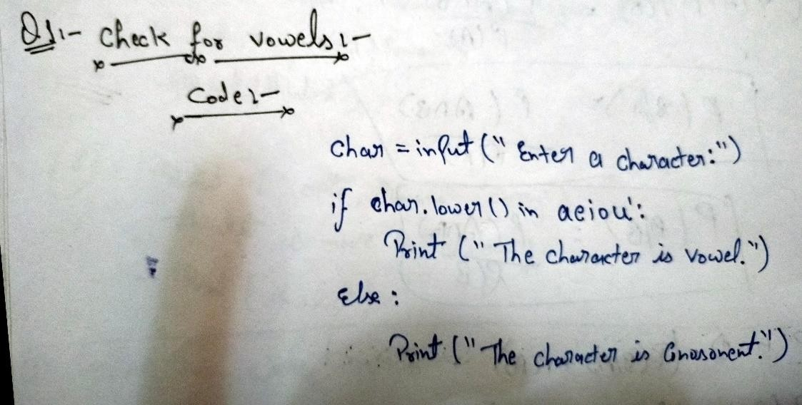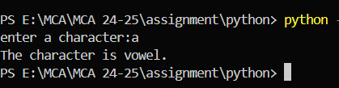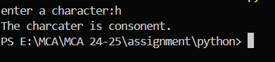

## Index Page

**Student Information**

* **Name**: [ATUL KUMAR]
* **Student ID**: [590011190]
* **Branch**: [MCA]
* **Batch**: [B1]
* **Instructor**: [**Abhirup Khanna**]
* **Date**: [27/07/2024]

# Assignment Questions

**Question 1: Check for Vowels**

**Task:** Write a program that checks if a given character is a vowel or consonant. The program should take a character input from the user and use conditional statements to determine and print whether it is a vowel or consonant.

**Output:-**

## Question 2: Sum of Elements in a List

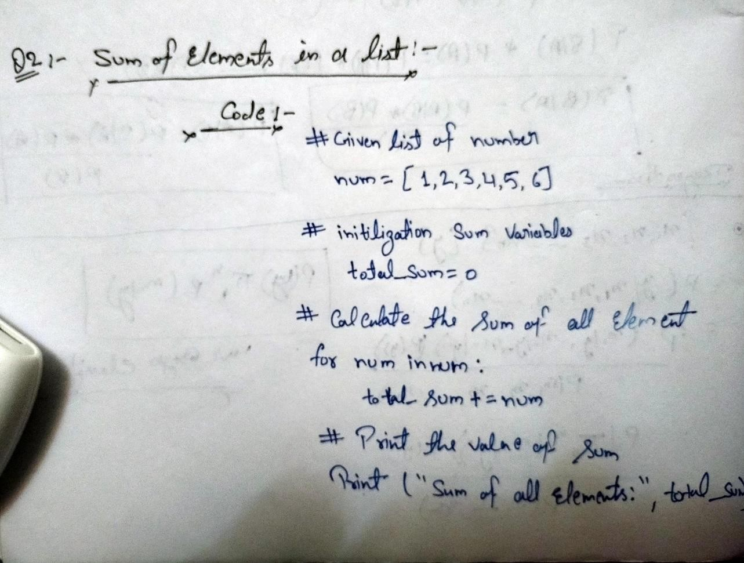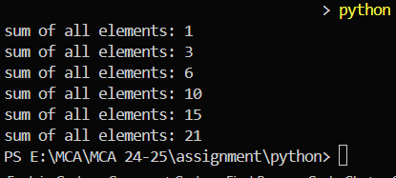

**Task:** Write a program that takes a list of integers and calculates the sum of all the elements using a loop. Print the sum.

**Output:-**

## Question 3: Reverse a String

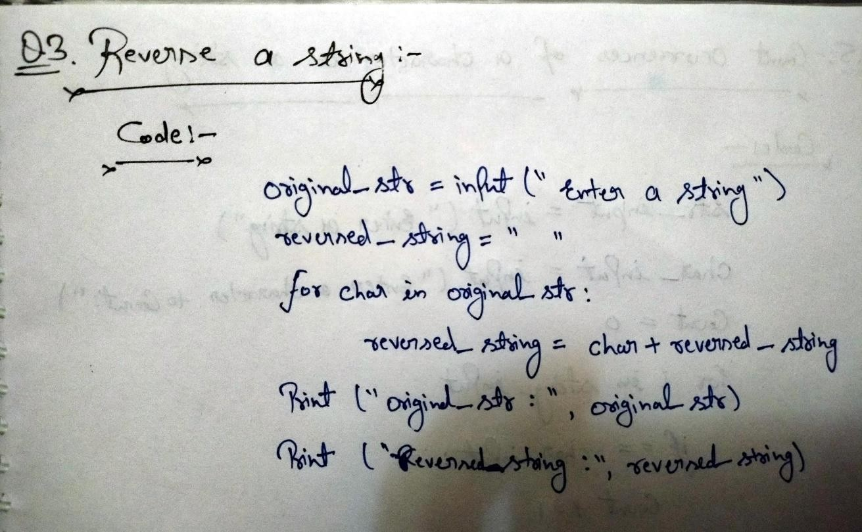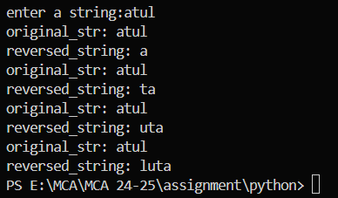

**Task**: Write a program that takes a string input from the user and prints the string in reverse order using a loop

**Output:-**

## Question 4: Find the Largest Number in a List

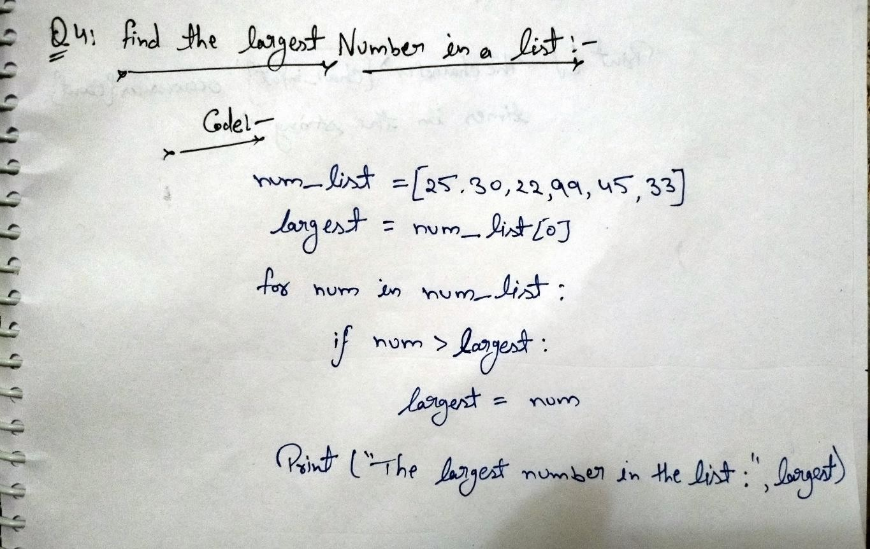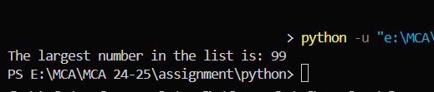

**Task**: Write a program that takes a list of integers and finds the largest number in the list using a loop and conditional statements. Print the largest number.

**Output:-**

## Question 5: Count Occurrences of a Character in a String

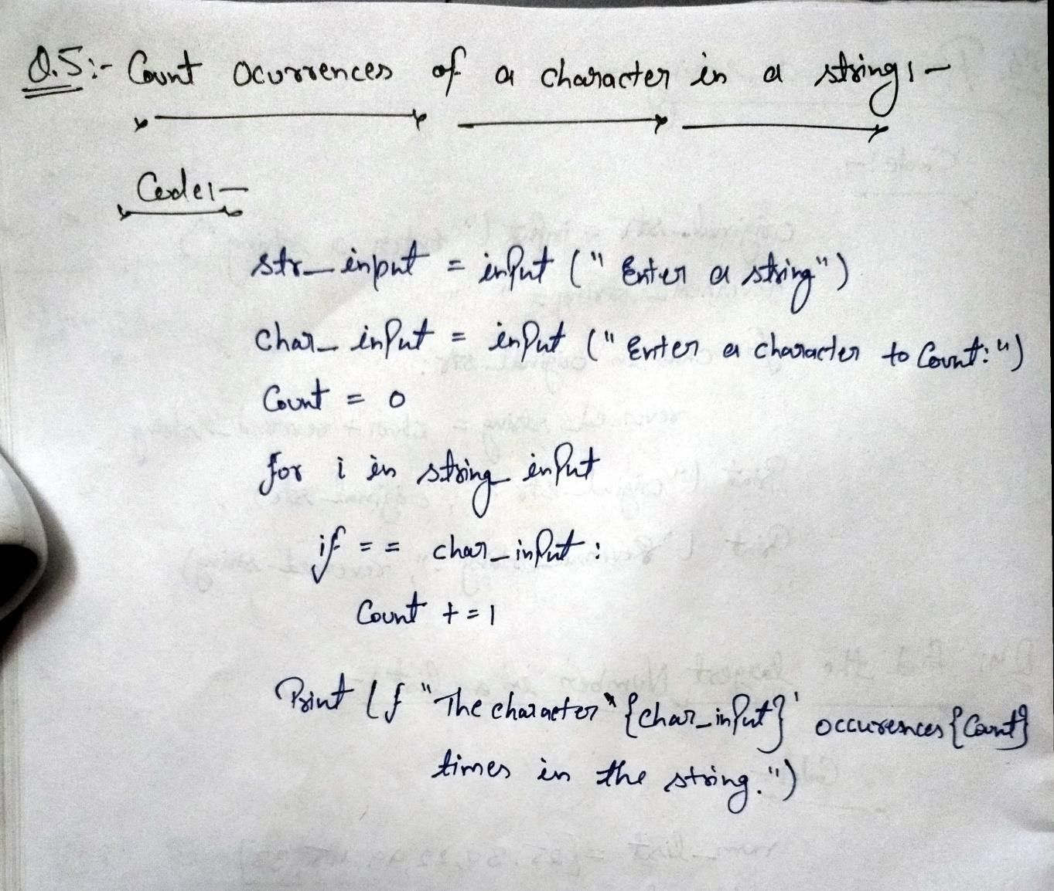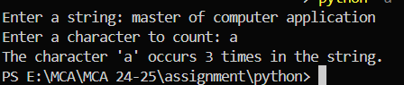

**Task**: Write a program that takes a string and a character as input from the user and counts the number of occurrences of the character in the string using a loop and conditional statements. Print the count.

**Output:-**



THANK YOU